Testing observability demo
Create resources using Azure DevOps Terraform pipeline
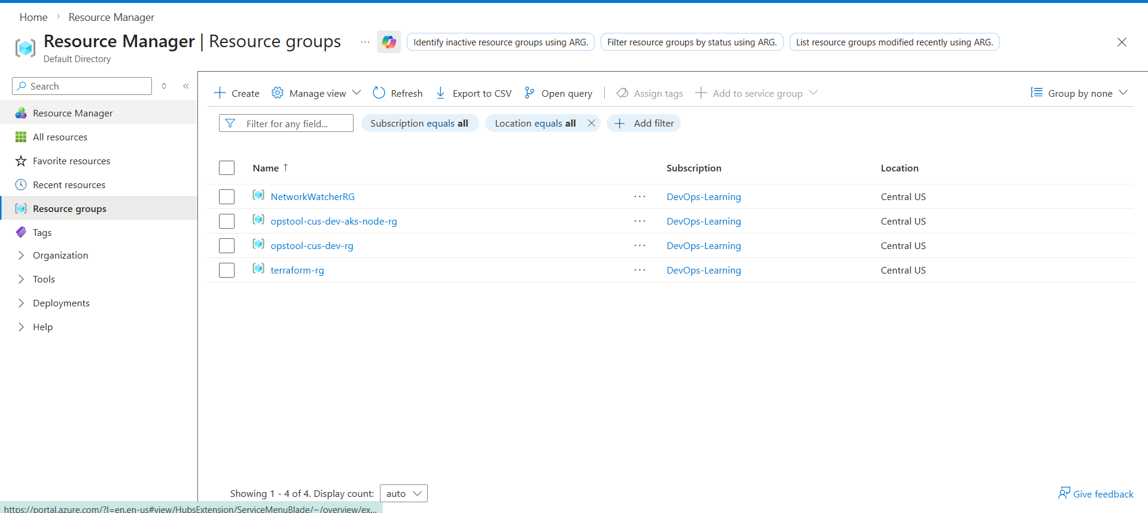

Ensure AKS is in running state and add yourself as an RBAC Cluster Admin
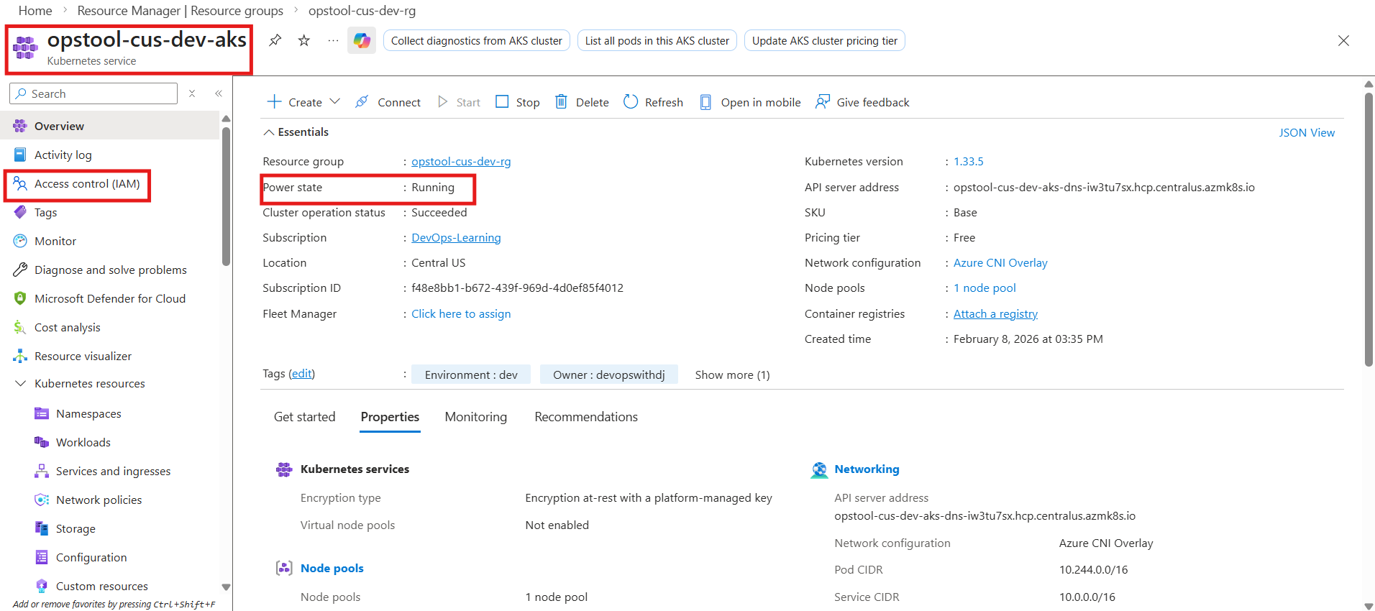
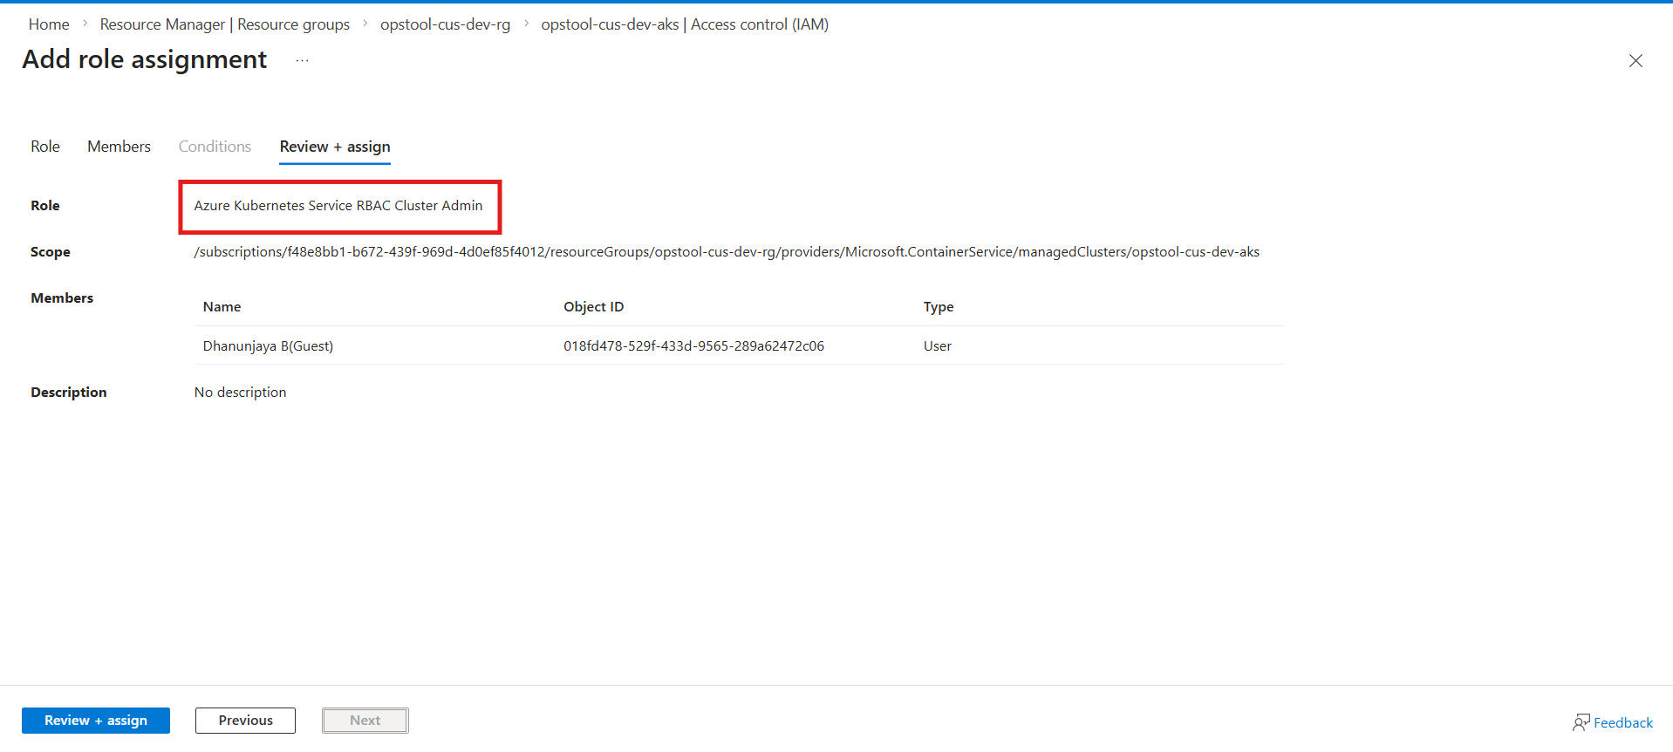
Then connect to AKS from local using connect option and commands
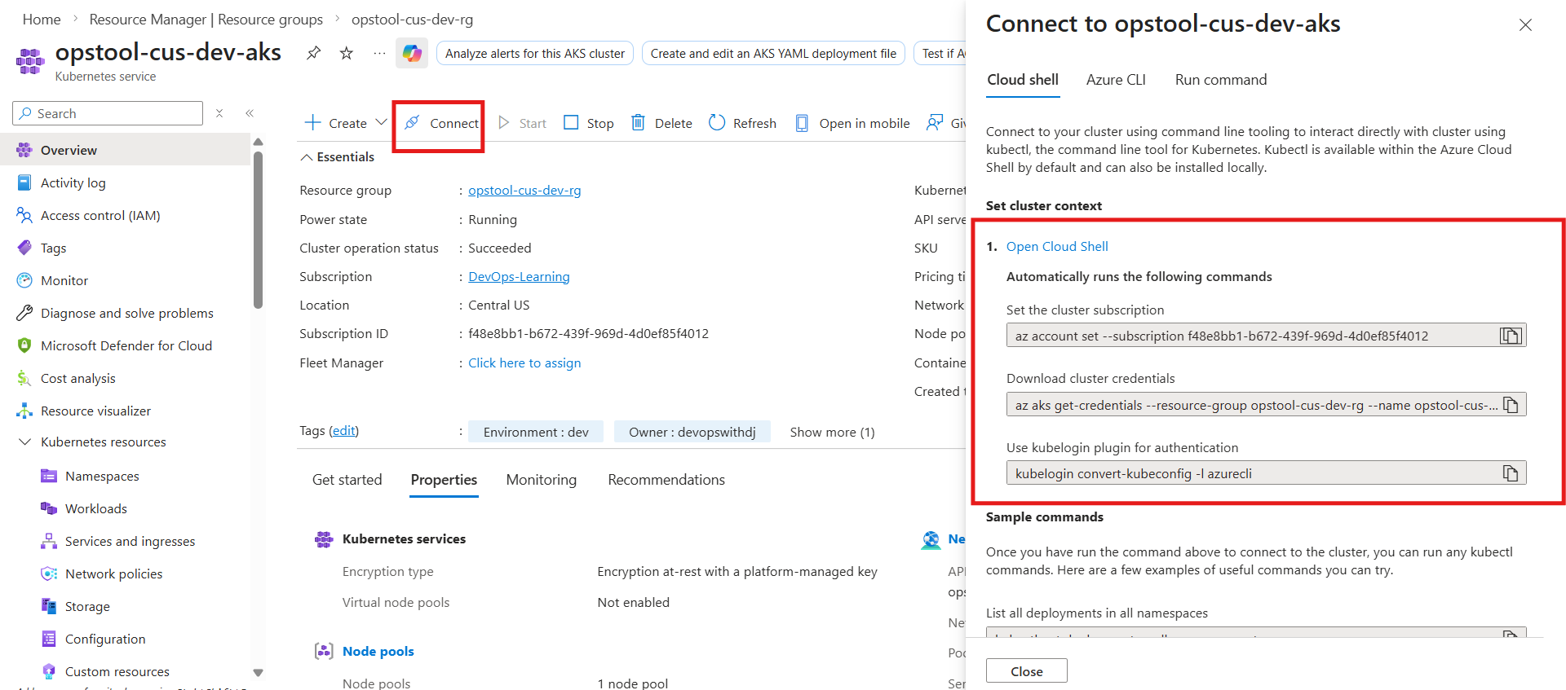

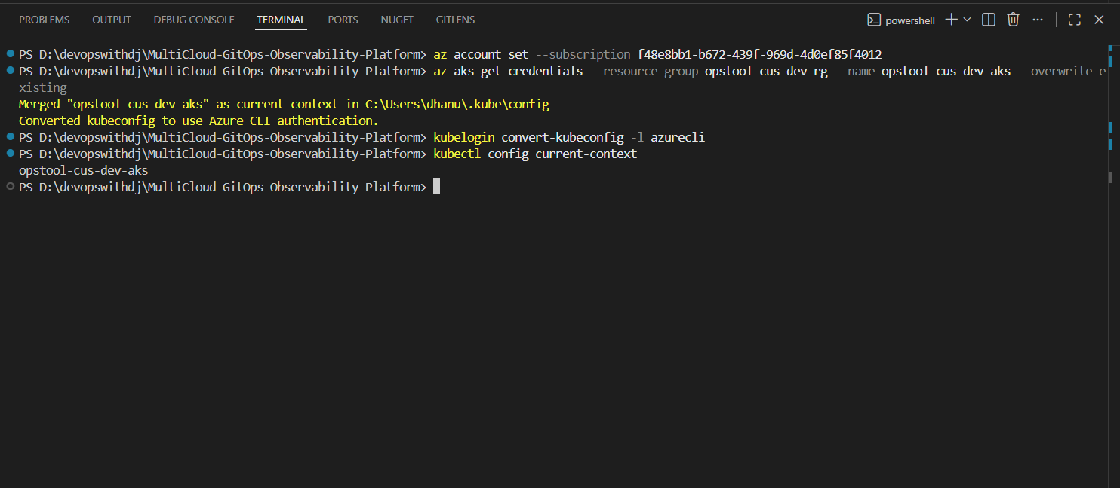

Now follow the documentation for https://opentelemetry.io/docs/demo/kubernetes-deployment/
helm repo add open-telemetry https://open-telemetry.github.io/opentelemetry-helm-charts
helm install my-otel-demo open-telemetry/opentelemetry-demo
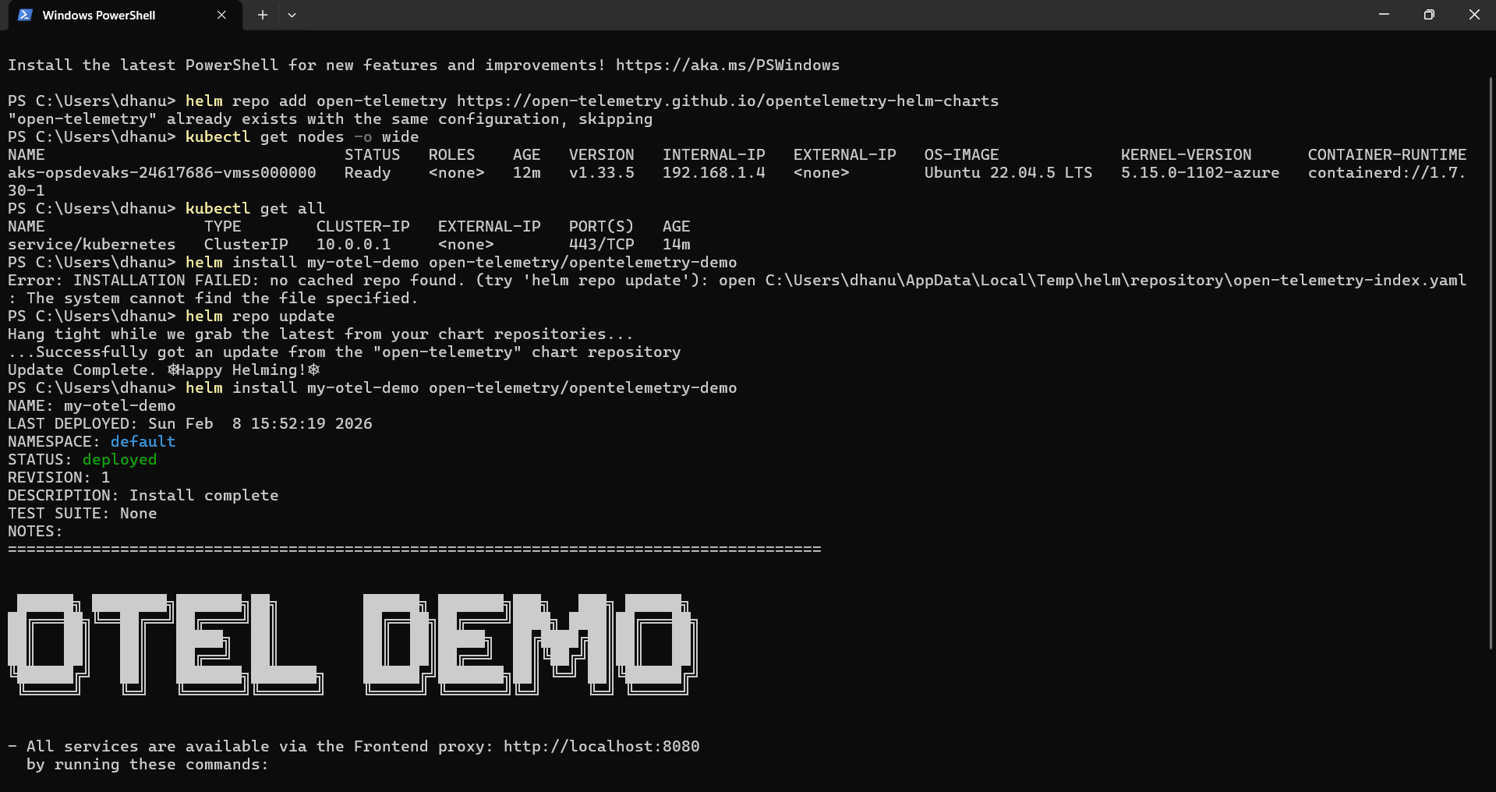

Architecture of Otel application
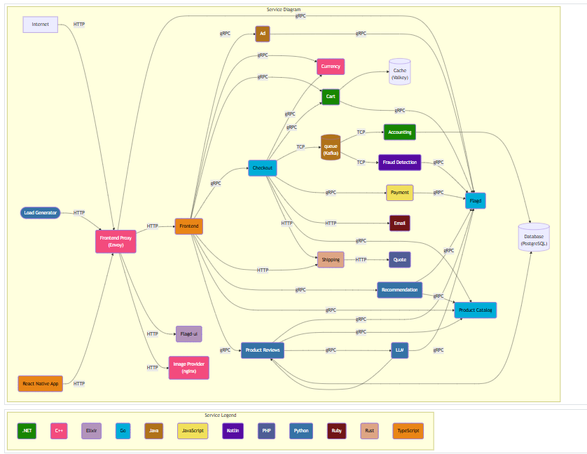

Now we can play around the open telemetry application.
Pods of all the services are running.
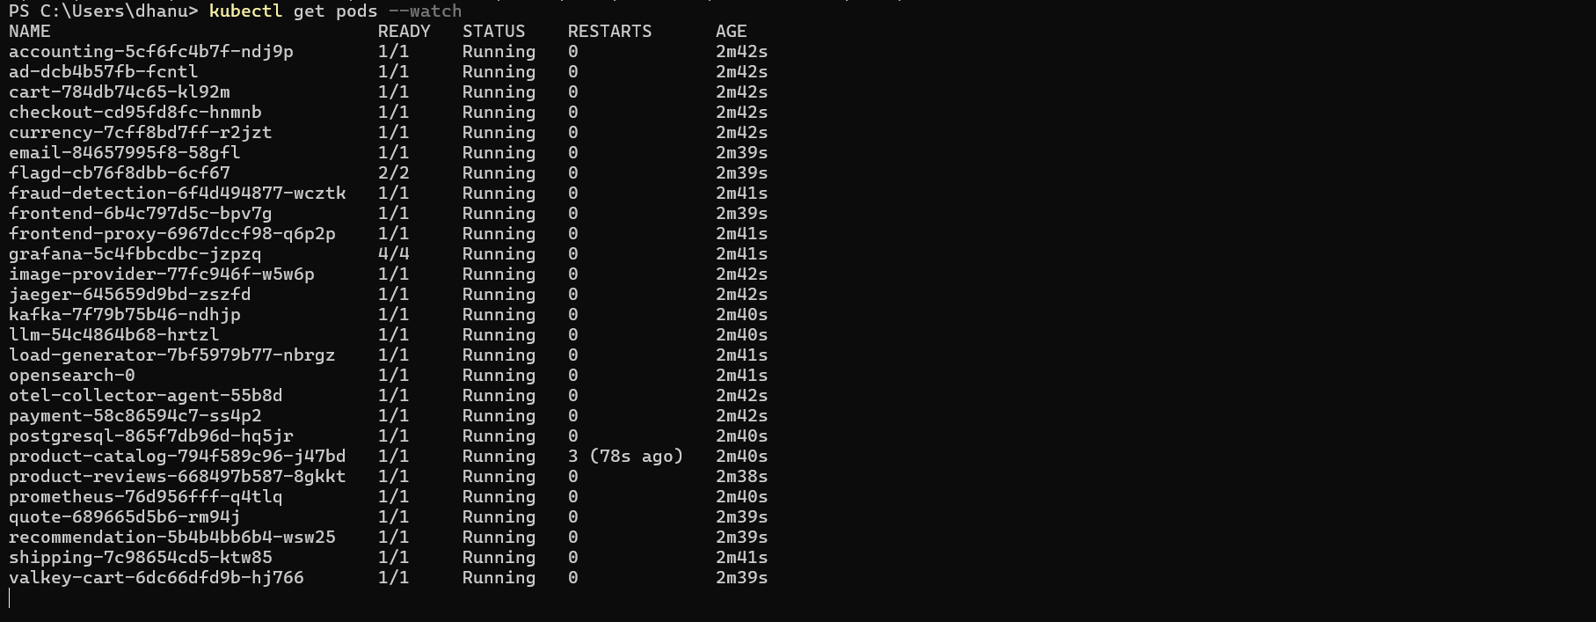
Services that are deployed
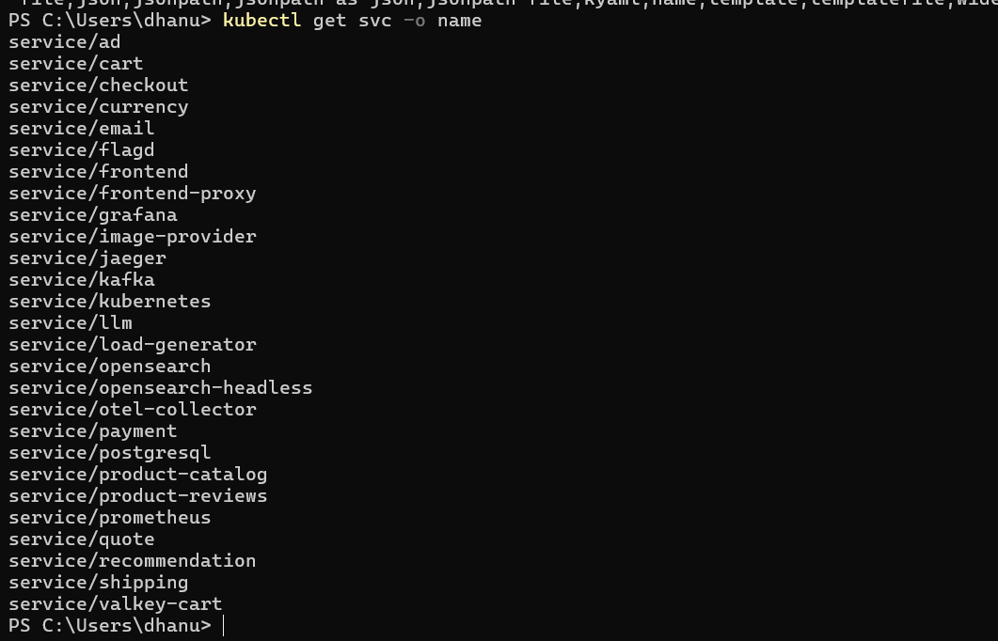
Voila

Telemetry Demo application is up and running
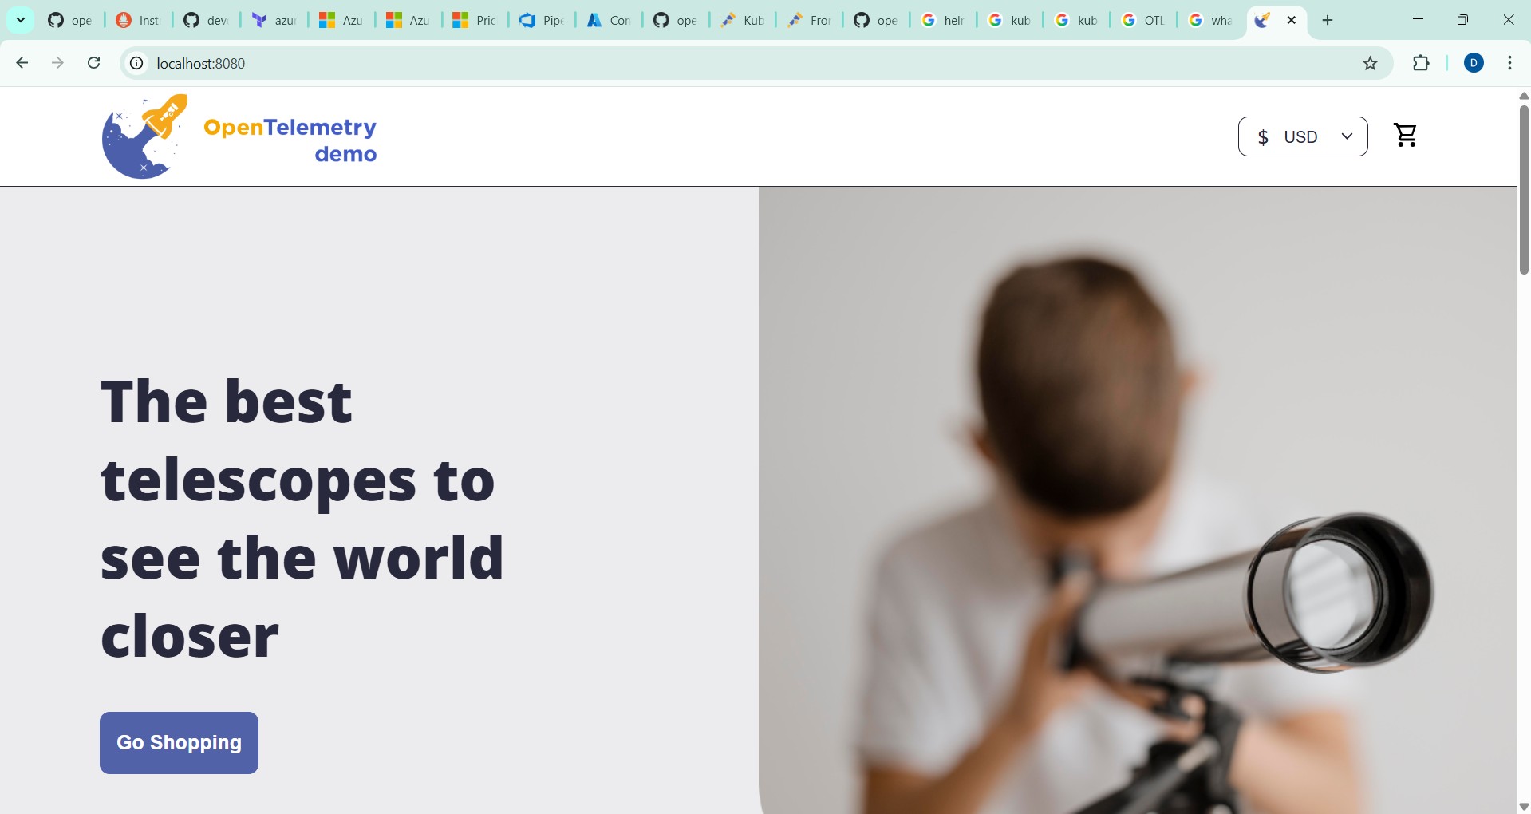
Locust Load generator
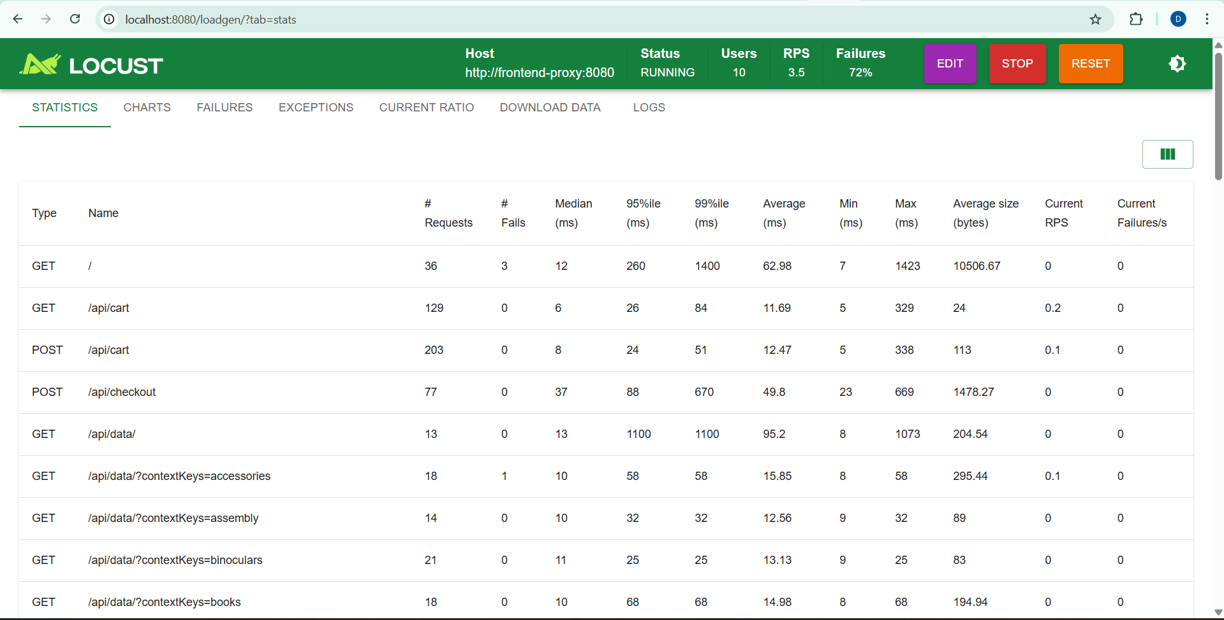
Grafana UI
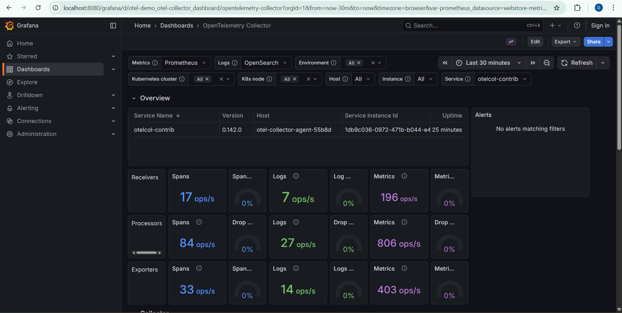

Jaeger UI
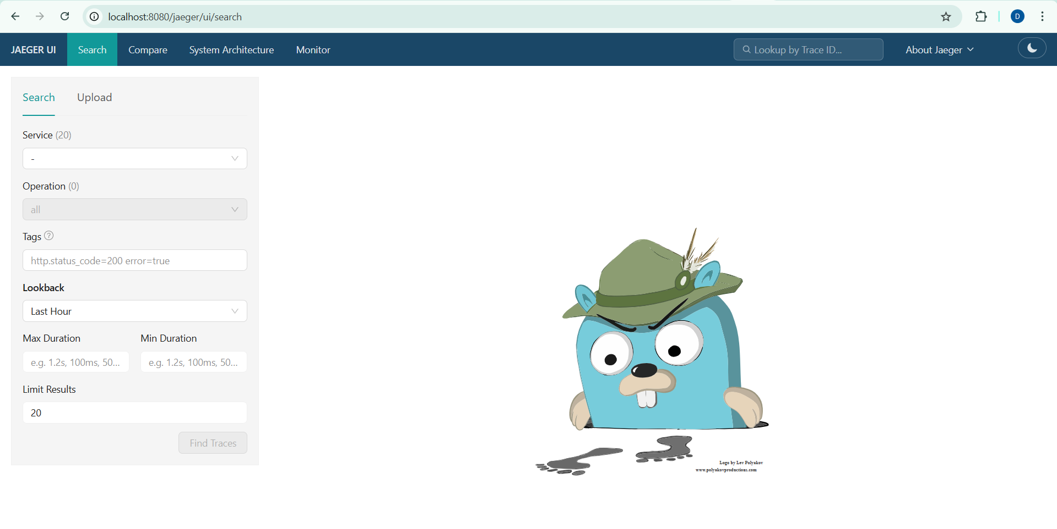
FlagD UI
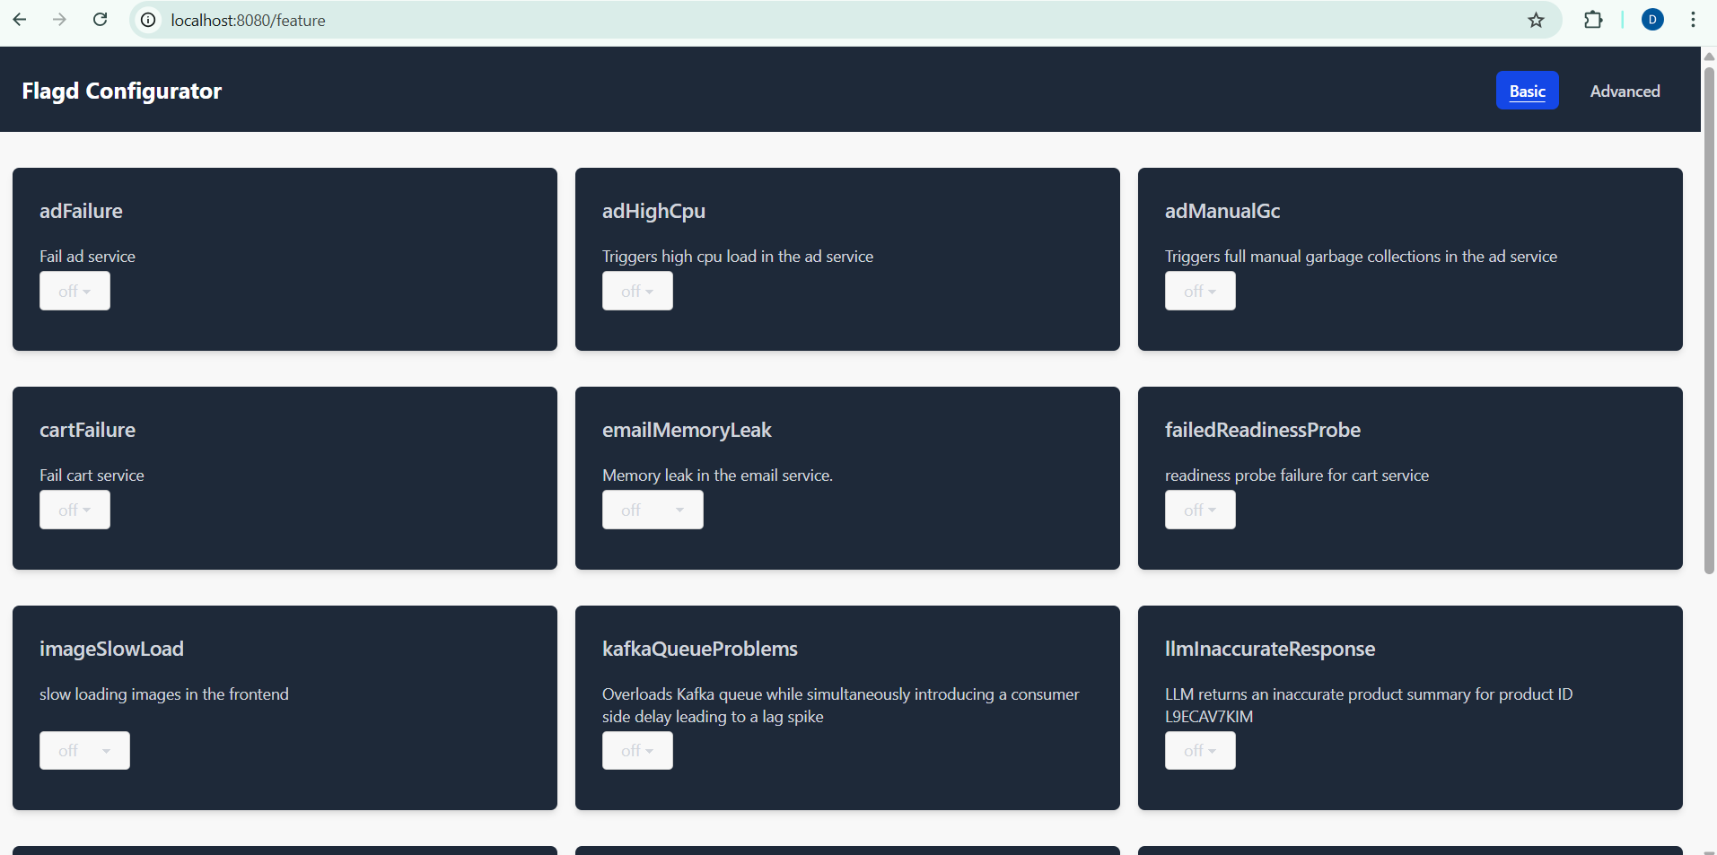

Play around on Frontend UI and u can observe each service working.
Example
Added an item to cart
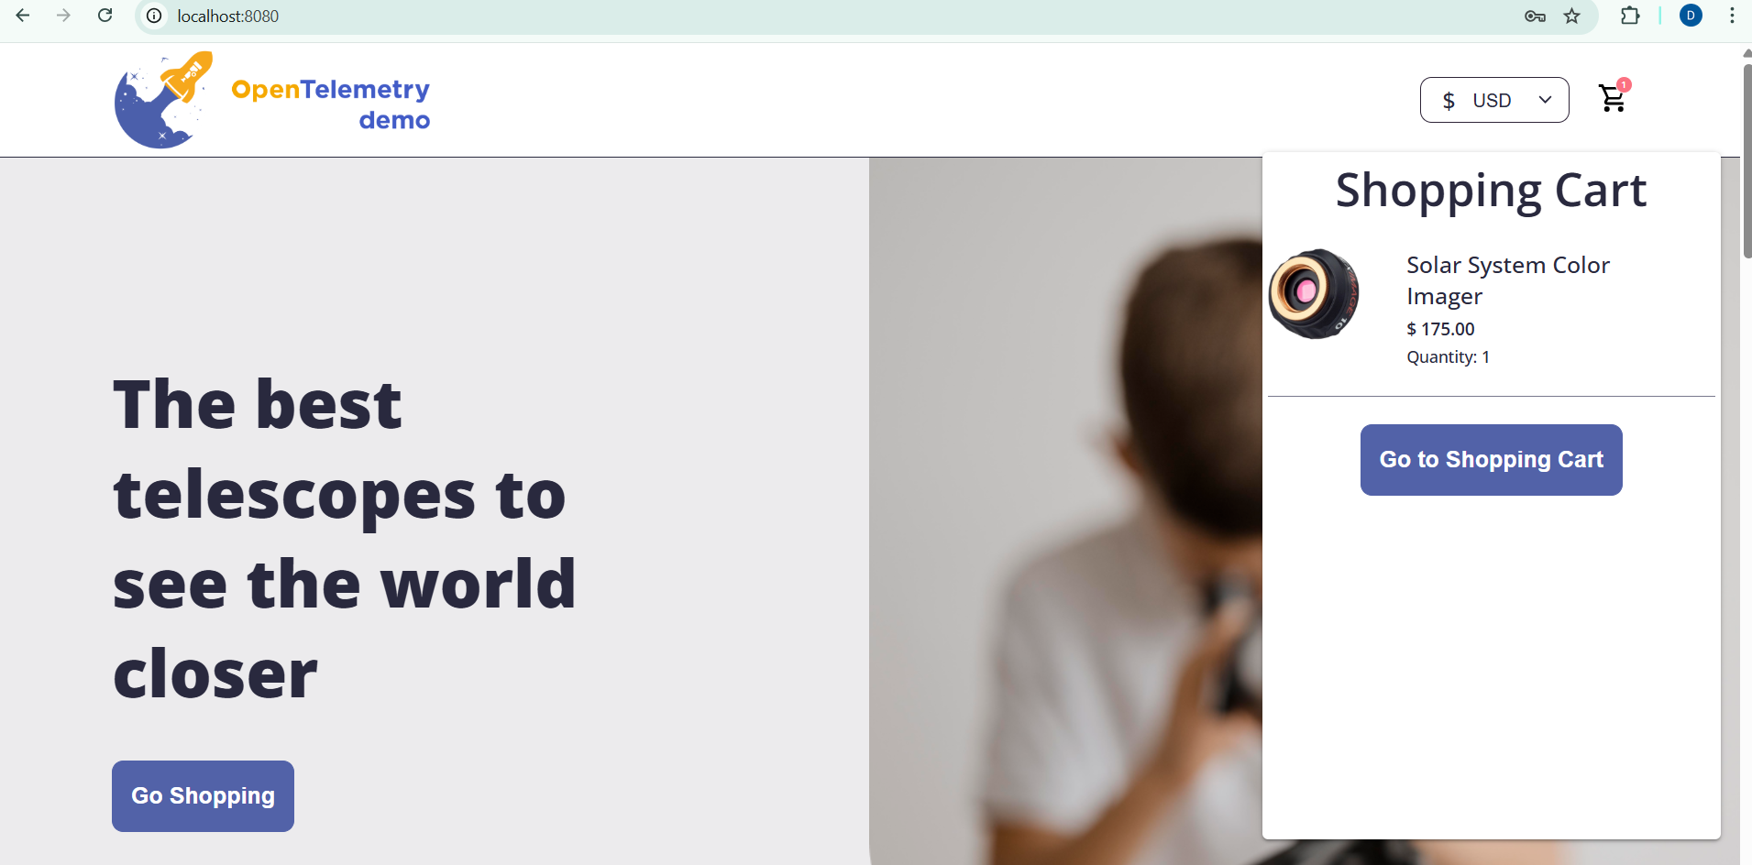
Locate the traces in Jaeger – understand the flow of the application calls.
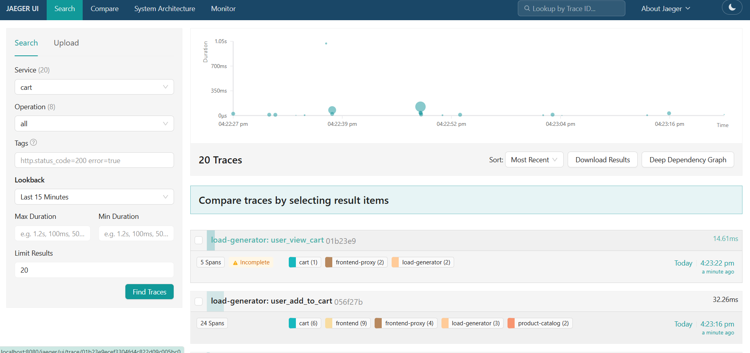
Look through spans for detailed flow
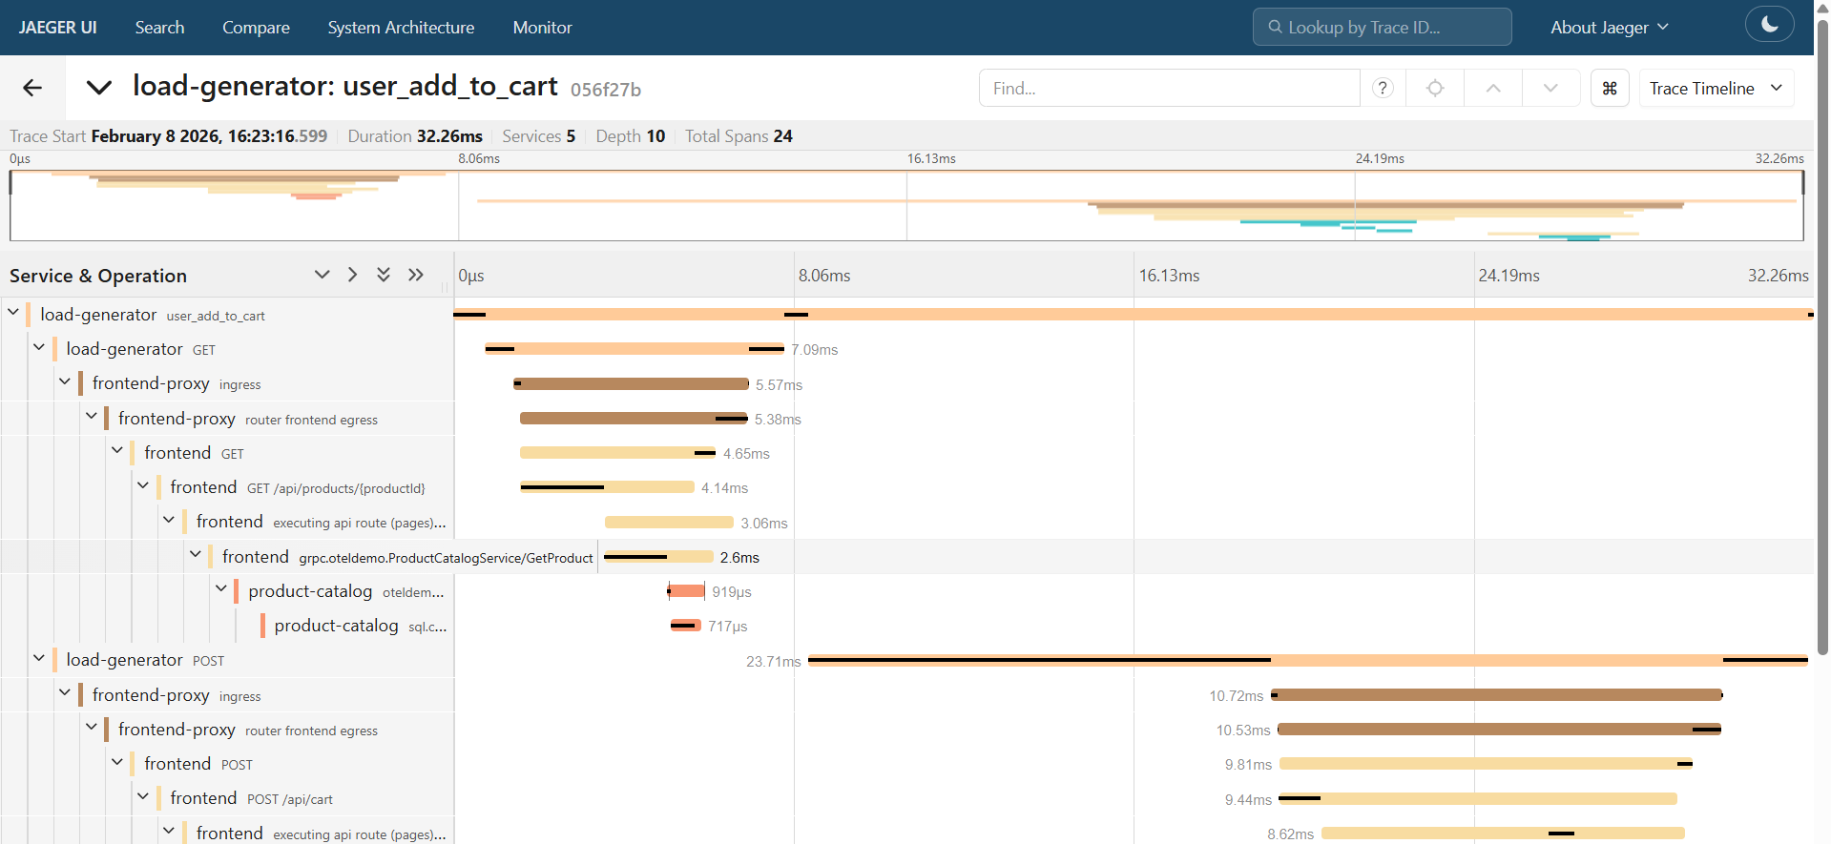
Similarly you can explore the other services as well.
Once tested you can uninstall the helm to remove the services and further delete the AKS to avoid incurring costs
helm uninstall my-otel-demo

